|  |
| --- |
| 让气象气候拉起手来 |
| 计算机建模专家打造领先天气预报模型 |

科学网

http://news.sciencenet.cn/htmlnews/2017/4/374524.shtm

https://www.science.org/content/article/take-europe-computer-modeler-aims-give-us-lead-weather-predictions

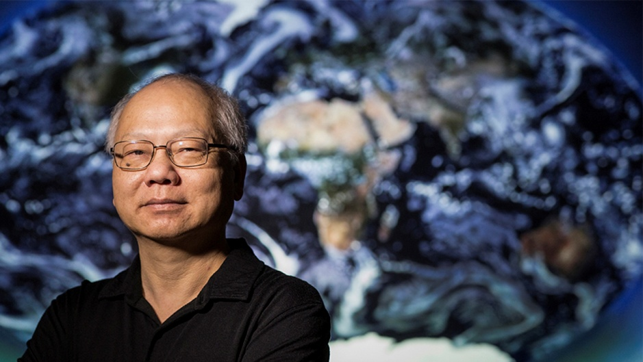

From below the conference table comes the thrum of incoming phone alerts. The new weather forecast has rolled in, and the climate scientists, even though it's not typically their business, dig out their phones to look: snow tomorrow—hardly unusual for early February in Princeton, New Jersey. But the weather models have the storm breaking severe, dumping a foot or more. A snow day seems likely.

Across the table at the Geophysical Fluid Dynamics Laboratory (GFDL), Shian-Jiann "S. J." Lin is not convinced. He is the master of 20,000 lines of computer code that divide the atmosphere into boxes and, with canny accuracy, solve the equations that describe how air swirls around the globe. For decades, Lin's program has powered the long-term simulations of many climate models, including GFDL's—one of the crown jewels of the U.S. National Oceanic and Atmospheric Administration (NOAA). Now, Lin's domain is expanding to a different side of NOAA: the short-term weather forecasts of the National Weather Service (NWS). By 2018, Lin's program will be powering a unified system for both climate and weather forecasting, one that could predict conditions tomorrow, or a century from now—and do it faster and better than current models. His work will soon be guiding mayors planning not just for snow plows, but also rising seas.

But Lin has started early. His small team is already running a prototype forecast on their supercomputer. And in his typically confident and brash style, he offers a minority report about the next day's storm.

"If our forecast is correct, it's only 3 to 6 inches," Lin announces. His peers at the table seem skeptical. "It's going to be a mess," one warns. But Lin doesn't budge. He rarely needs to. "We'll see what we get tomorrow," he says. "You want to bet?"

Much is riding on Lin. Recently, NWS has suffered some prominent embarrassments, such as in 2012, when it predicted Hurricane Sandy would sputter out over the ocean while a leading European center accurately forecast the direct hit on New York City. Fed up with the country's second-place status, Congress in 2013 poured $48 million into NWS weather modeling. The message for NOAA was clear: Get America on top.

This drive has opened up an opportunity. For a long time, meteorologists and climate scientists operated in separate domains. Meteorologists focused on speed: ingesting as many data as possible from satellites, balloons, and buoys and quickly spinning it into a forecast. Climate scientists focused on the fussy physics of their models to produce plausible simulations over decades. But now, the two groups are discovering common ground, in "subseasonal to seasonal" predictions—from a month to 2 years out. In order to push forecasts beyond 10 days or so, meteorologists need the superior physics of the climate models. Meanwhile, climate scientists want to know how weather phenomena that happen on monthly or annual timescales, like El Niño, influence the global climate. "The two cultures are speaking each other's language, and realizing they're going to live and die together," says John Michalakes, a computer scientist who develops atmospheric models at the Naval Research Laboratory in Monterey, California.

There could be another benefit to blurring the lines between weather and climate, one that climate scientists are loath to talk about explicitly. Although studies of human-driven climate change have faced scrutiny and scorn from conservative politicians in the United States, weather research remains solidly bipartisan, says David Titley, director of the Center for Solutions to Weather and Climate Risk at Pennsylvania State University in State College. Just this month, for example, Congress passed a weather forecasting bill that dedicates $26.5 million of NOAA's budget to improving its seasonal predictions, and climate change doubters were among the supporters. "If I were running the world, I would keep that divide vague," Titley says.

In his modeling, Lin never made the distinction. "From the beginning we talked about how there is no difference between weather and climate," says Ricky Rood, an atmospheric scientist at the University of Michigan in Ann Arbor and Lin's longtime collaborator. But others haven't wanted to hear that message—and especially not from Lin, who is as feisty and fractious as a government employee can get. "It's amazing to me," says Rood, "that S. J. could evolve to be a source of unification."

Storms have roiled around Lin his whole life. Typhoons are regular events in Taipei, where he grew up, and he was always fascinated by their power. "I have hurricanes in my blood," he says. Born in 1958 to parents who ran a small construction company, he was the first in his family to go to college. As a student at National Taiwan University, he studied microprocessor architectures, along with meteorology and fluid dynamics. He became fascinated with the challenge of rendering the continuous currents of the atmosphere in the discontinuous, 0-or-1 world of computer code.

At the time, Taiwan was a dictatorship, and Lin joined student groups opposed to the regime. After college, he faced several years of mandatory military service. He aced his entry test and assumed he would land a cushy engineering job in Taipei. Instead, he was shipped to the Matsu Islands, 16 kilometers from the Chinese mainland. He was hardly a model soldier. He hated having to recite party doctrine during assemblies. "You had to pretend, and say something not in your heart," he says.

Taiwan didn't seem to have a place for him, so in 1983 he enrolled in the aerospace engineering department at the University of Oklahoma, one of the only schools he could afford. He wanted to be a rocket scientist. But it was a tough transition. He cared more about learning computer languages than English, and felt isolated. His accent is a barrier, but not the only one. "Some folks tend to have a difficult time following S. J.," says Bill Putman, a meteorologist at NASA's Goddard Space Flight Center in Greenbelt, Maryland, and another longtime collaborator. "But it's not necessarily a language barrier. It's more a knowledge barrier." Seeing his talent for computational fluid dynamics, his adviser suggested Lin switch to Princeton University, which with its partnership with GFDL is a hotbed for atmospheric modeling.

He learned how GFDL scientists divided the air into a 3D grid that spanned the globe and stretched from the surface to the stratosphere, following lines of latitude and longitude. Along points on the grid, they would set initial conditions—the weather or climate for a given moment in time. Then, point by point, the computer would solve equations describing changes in wind, air pressure, temperature, and humidity for successive steps in time. Computers were room-sized mainframes at the time, and the model grids were huge, with a mesh size of 500 kilometers. The models could recreate only the largest atmospheric features, like jet streams and the Hadley cell, the belt that circulates warm air from the equator to the subtropics.

After graduate school, Lin decided to stay in the United States. "I'm now more American than I am Taiwanese," he says. He drinks whisky, but infuses it with ginseng. He returned to the University of Oklahoma as a postdoc to work on modeling tornadoes. But computers couldn't yet model events that unfold at such small scales. The failure was humbling, and Lin says it provided a mantra: "Choose the right level of complexity for the particular problem, at the time that you have the resources to do it." Lin soon found the right problem at NASA.

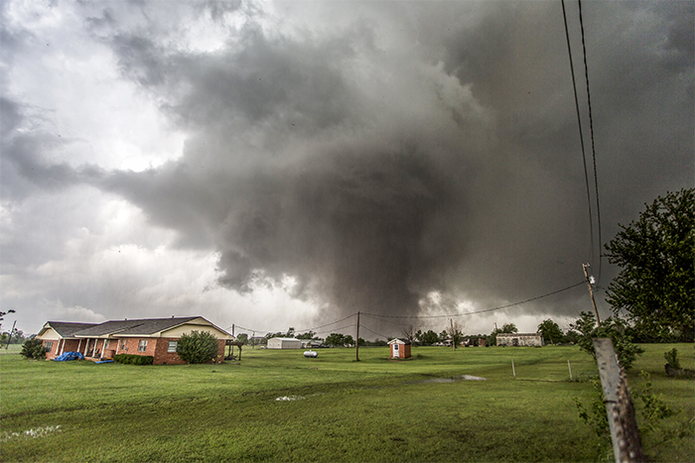

At high resolution, Lin's model can simulate tornadoes, such as the 2013 twister in Moore, Oklahoma, that killed 24 people.

VINCENT DELIGNY/AFP/GETTY IMAGES

In the late 1980s, Rood was working on the problem of the Antarctic ozone hole at Goddard. NASA was flying research planes into the hole to measure the chemicals that might be destroying it. These flights revealed a drop in several short-lived reactive nitrogen oxides, which allowed chlorine from humanmade chemicals to linger, priming further reactions that broke down the ozone. But Rood's atmospheric models couldn't simulate the flows and reactions. No matter what he did, the nitrogen reactants remained steady.

How could that happen? At the time, an elegant mathematical solution had overtaken global modeling, called the spectral method. Rather than solving at points on a latitude-longitude grid, scientists realized that fluid flow in the atmosphere could be represented as the sum of a series of hundreds of sinusoidal, crisscrossing waves. The code ran faster, and the results could be transformed back onto a regular grid. The spectral method still powers most global weather forecasts today, including at NWS. But the speed comes with a cost: When the waves are projected back into physical space, mass can gradually grow unbalanced. For weather models, which only run for days into the future, this is not a big deal. But for models of atmospheric chemistry and climate, which run for much longer periods, these distortions were a critical flaw.

Fortunately for Rood, a young Taiwanese scientist had written to him, lured by his publications. When Lin joined NASA in 1992 as a contractor, the two set out to build a model that, above all else, preserved mass. This first meant jettisoning the spectral method. It also meant upgrading from finite-difference modeling, which solves for points on a grid, to a finite-volume model, which solves for conditions averaged across each cell, or box, and is ideally suited for conserving mass because the calculations pass fluxes, or volumes, of material from one box to the next. Others had considered such a solution, but thought it too complex or computationally expensive.

But Lin was a master of computational efficiency. Over a furious few years in the mid-1990s, he and Rood expanded their model beyond chemical transport—for which it remains the standard—to a fullfledged dynamical core fast enough to be used for climate models. Put a mote of dust in the air, says Paul Ginoux, an aerosol modeler at GFDL, who also worked with Lin at Goddard, "and this code will transport it at the right place, at the right moment. And that's beautiful." The name of the code was far more mundane. They called it "FV," for finite-volume, and later FV3.

Their work soon drew the attention of the National Center for Atmospheric Research (NCAR) in Boulder, Colorado, one of the country's leading institutes for weather and climate science, which incorporated FV into its influential climate model. NASA's climate laboratory in New York City adopted it as well. And in 2003, GFDL lured Lin away to upgrade FV and fold it into its global simulation. The results of these models, some of the top U.S. contributions to the United Nations panel on climate change, have informed much of what the public hears about global warming. And they've all had Lin's innovations at their heart.

There's a term of art at NOAA for the reactive way Congress finances weather research: "budgeting by disaster." It's rarely pretty, and it's why the coming merger in atmospheric modeling will, at its root, be thanks to the calamities of Hurricane Katrina and Hurricane Sandy.

In 2005, after NWS failed to forecast Katrina's direct hit on New Orleans, Louisiana, until 2 days out, Congress set aside money to improve predictions of Atlantic hurricanes. As it happened, it was around this time that Lin walked into the office of his boss at GFDL, Isaac Held, and declared: "I'm going to revolutionize weather prediction." Computers were now capable of processing boxes small enough to render hurricanes. More important, Lin had developed a key bit of physics needed for FV3 to forecast realistic hurricanes. Many global forecasting models operate using an assumption called the hydrostatic principle—where the gravity of the air in any box is exactly balanced by the upward force of the air pressure in the box below it. This works for coarse models, which cannot directly simulate the fine upward and downward flows in the real atmosphere. But recreating weather events like hurricanes and thunderstorms, where updrafts are important, requires breaking this hydrostatic principle. After a decade of mulling, Lin finally had an efficient way of incorporating nonhydrostatic flows into his code.

He needed to test it. Frank Marks, who leads hurricane research at NOAA's Atlantic Oceanographic and Meteorological Laboratory in Miami, Florida, was overseeing improvements for the regional hurricane model for the Atlantic basin. With a smaller area to model, Marks can afford to have fine-scale boxes. Lin convinced him to use Katrina dollars to buy extra supercomputer time. Run FV3 at a 1-kilometer resolution, Lin promised, and the finest details of cyclones would arise. Sure enough, the violent walls of a hurricane's eye opened in his code.

**Zooming in on storms**

The FV3 model divides the atmosphere into boxes and simulates conditions in each one. To avoid problems at the poles, its coordinates are based on a cubed sphere. The program can also nest grids to simulate weather at different scales.

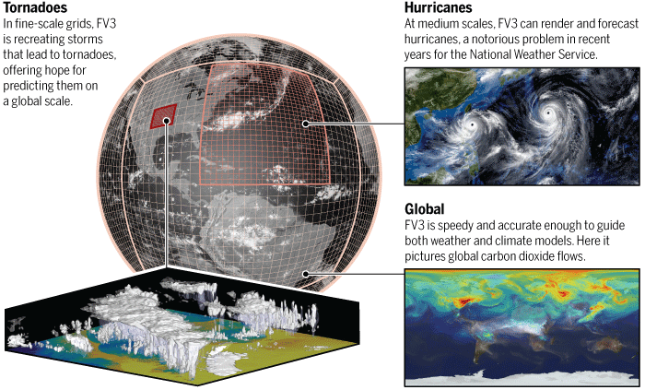

IMAGES: (CLOCKWISE FROM LEFT) LUCAS HARRIS, NOAA/GFDL; C. BICKEL/*SCIENCE*; XI CHEN (PRINCETON UNIVERSITY); NASA'S GODDARD SPACE FLIGHT CENTER

In 2014, when NOAA announced a competition to choose the "core" of the agency's next-generation weather forecast system, Lin was ready.

Five models were entered, including FV3. And by the summer of 2015, FV3 was one of two frontrunners, along with the Model for Prediction Across Scales (MPAS), the globalized version of a long-standing system produced by NCAR and used by many researchers. They would be judged on their speed and accuracy in mimicking the atmosphere's flows.

For 6 months, Lin's placid office turned frenetic, as his team worked nights and weekends to embed FV3 within the weather service's system. "There was never a time where I thought we were losing the battle on scientific ground," Lin says. One advantage of his model was efficiency. It is Lin's obsession—and not just at work: When Hurricane Sandy knocked out power at Lin's modest home, he refused to use a normal generator, and instead rigged his Prius up to his home wiring. Its battery, he explained, would make certain any extra electricity the car's generator churned out wouldn't go to waste.

So that FV3 could make efficient use of limited computing power, Lin and his team had written the code to work in parallel. This is hard for global models, where the weather in one box can influence another box a hemisphere away. But this interconnectedness isn't as big a problem in the vertical dimension, so Lin enabled FV3's layers to be detached from each other and be processed in parallel. He won additional efficiencies by changing the shape of the grid. Climate models are plagued by the so-called pole problem, the result of the strangely squished and stretched boxes near the poles. So Lin and Putman, his former NASA colleague, abandoned the latitudelongitude system in favor of a cubed sphere. Picture a six-sided die inflated like a balloon. There were no more poles to handle, just six square panels, with tricky interactions at the seams.

The net result: compared with MPAS, FV3 took a third as many computer processors to run at operational standards. It also outperformed MPAS when run on a vast number of processors, and it could zoom in to model one part of the globe at high resolution without skewing its performance in coarser regions. It was a slaughter. NCAR withdrew its model before NOAA anointed FV3 as the winner, in July 2016. "There was just never any conclusive evidence that MPAS had an advantage that was worth the cost," says Michalakes, who led the computing comparisons.

During the competition, Lin had complained that NOAA was biased in favor of MPAS; now, he crows about his victory. "Most people in that discipline paid no respect to what we had been doing," he says. "They found out the hard way." With NCAR toppled, Lin now faces far bigger rivals: the United Kingdom's Met Office, which since the early 1990s has been the only center to have merged its weather and climate forecasts, and the European Centre for Medium-Range Forecasts, which has long run the top-rated weather model.

This time around, he'll need help.

European modelers start with the same set of balloon, satellite, and ground measurements as everyone else. But they cleverly inject randomness into these initial conditions, then do multiple runs to come up with a "consensus" forecast. Getting the United States up to those standards will require winning over U.S. researchers to provide innovative techniques that Lin and his colleagues can adapt for their model.

Yet there's a risk that academic weather scientists will avoid using FV3 and instead stick with MPAS, more comfortable with its origins and documentation, says Cliff Mass, an atmospheric scientist at the University of Washington in Seattle. Lin's reluctance to break down his code in the past has heightened concerns. "Lin is a brilliant modeler," Mass says. "He's not big on community support." But Putman believes Lin will embrace true improvements. "If he sees something that will push this code beyond where it is now, I'm sure he's willing to adapt."

At a workshop next week, NWS will lay out its aggressive timetable for turning on FV3. By this May, FV3 ought to be fully wired into the service's data assimilation. And by the first half of 2018, if all goes well, NOAA will flip the switch, making it the standard forecast that feeds into all of our phones.

Meanwhile, Lin's team continues to tinker with FV3. They're honing a more powerful zooming technique: allowing the grid to create nests of high-resolution boxes, 2 to 3 kilometers a side, over regions of interest. This could allow high-resolution hurricane forecasts to be run at the same time as global predictions, with no need to wait for the global run to finish. And it could capture tornado outbreaks and severe storms, weather that has been too finegrained for existing global models. "We're kind of ambitious," Lin says. "We're trying to cover everything."

On a screen at GFDL, Lucas Harris, Lin's deputy, zooms in on Oklahoma, where a nested FV3 grid is recreating the events of May 2013. It was that month that a severe twister plowed through Moore, Oklahoma, killing 24. As the model runs, scattered storms organize into a line of squalls. Then anvil clouds form—the thunderstorm cells from which tornadoes would touch down on Moore. Next, Harris changes the place and time, to the eastern United States in June 2012, when a bow of thunderstorms—a so-called derecho—caught forecasters off guard and in some areas knocked out power for a week. The model sees traces of the storm nearly 3 days in advance. "Previously," Harris says, "it was believed there was only 12 hours of predictability to this event."

So far these results have stayed in the lab, but Lin is doing his best to spread the gospel. For the 2017 hurricane season, his prototype will run alongside existing regional hurricane models. And next month, Lin will return to Oklahoma for the "Spring Experiment," a research jamboree of severe storm scientists, to test how the zooming technique could help local forecasters.

All this collaboration, this dependence on outside contributions, makes Lin nervous. His model is moving out of the lab into the messy real world. Will it become the bedrock of all weather and climate prediction, from tornadoes next week to temperature rises next decade? "I'm cautiously optimistic, but not overly optimistic," he says.

A good omen comes the next morning. Snow blankets Princeton—beautiful, but also manageable. Nearly 6 inches fell, not a foot or more. GFDL could have stayed open. Over the ether, Lin can't resist a final comment. "The snow," he writes, "is not as bad as forecasted."

*A previous version of this story incorrectly stated that FV3 scaled more efficiently than MPAS. In fact, the incremental performance improvement of MPAS with additional computer processors—its scalability—was better than FV3's, although FV3 outperformed MPAS on tests of more than 100,000 processors. Also, John Michalakes's title was clarified: He is a computer scientist who works on atmospheric models, not an atmospheric scientist.*

doi: 10.1126/science.aal1038

# 好用，不好用？用，还是不用？ 美国新数值预报模式面临抗议风暴

<http://www.zgqxb.com.cn/zx/gj/201903/t20190307_516675.html>

来源：中国气象报 日期：2019年03月07日10:09

　　近日，美国国家气象局（NWS）宣布，一个称为GFS-FV3的全球数值预报模式将在今年3月20日全面投入使用，正式取代GFS模式，成为新的美国天气预报模式。

　　GFS，即Global Forecast System，中文为“全球天气预报系统”，通常被称为“美国模式”，已经以各种形式应用了30多年。2014年，美国启动下一代天气预报模式研发计划。2016年7月，美国国家海洋和大气管理局（NOAA）宣布，FV3（Finite-Volume on a Cubed-Sphere，立方球有限体积）模式从6个候选模式的PK中最终胜出，将成为美国下一代天气预报模式的动力核心模式，并在3年内开发出下一代预报系统。

　　如今，“三年之约”已至。GFS-FV3正式揭开面纱的这一时刻，也比以往更受期待。

　　考虑到天气对经济的巨大影响，在预报员没有足够把握进行预测的天气事件上引入数值预报模式，每年产生的价值可达4850亿美元。引入FV3，是NWS朝着建立世界上最好天气预报模型前进的重要一步，这也是特朗普政府的“公开优先事项”。目前的GFS模式在精确度上落后于欧洲模式（简称EC模式），而且多年来一直如此。尽管从2012年美国遭遇飓风“桑迪”袭击之后，美国国会已经投入了数百万美元资金用以改进GFS模式。

　　FV3是由NOAA地球物理流体动力学实验室（GFDL）开发的。当年FV3最终胜出，得益于该模式优良的特性。FV3升级使用了气候科学家在过去几年中开发的改进算法来描述大气和海洋之间的相互作用。这些算法捕捉了云形成、热带风暴和极地风等物理现象，然后对卫星和地面观测数据进行同化，生成三天或十天天气预报。

　　然而，在近几个月的公开测试中，许多使用过该模型的气象学家纷纷明确表示了它的“不可靠”。NWS的一位官员透露，由于这些投诉，GFS-FV3的正式“上岗”可能推迟。

　　几个月来，FV3的预测结论一直是公开的，用作预报员评估该模式的实验基础。结果却让许多人大失所望。当NWS打算把FV3用作美国主业务模式的消息传出后，气象学家在推特上发布了大量的抱怨和负面评论。

　　“这个新模式一点也不好。”美国国家广播公司首席气象学家道格·卡默勒在推特上写道：“可怕的是，这就是我们将要长期依靠并使用的东西。”

　　最近刚刚退休的美国知名气象预报服务公司AccuWeather高级副总裁迈克·史密斯在推特上写道：“我不认为FV3能比现在的GFS提供更好的天气预报。”

　　大量使用过FV3模式的气象学家担心，这一模式还没有准备好投入业务应用。而其中的关键问题之一，正在于该模式明显倾向于过度预报降雪。

　　卡默勒说，在过去的几个星期里，FV3一直在空报暴雪。它持续显示美国东海岸地区遇到了大规模的暴风雪，而EC模式不会显示这一点。

　　美国大气与环境研究公司气象学家尤达·科恩在推特上写道：“我对FV3降雪预报的能力没有信心。”该公司是一家为商业和政府客户提供天气预报的私营公司。尤达·科恩本人则以对极涡的长期预测而闻名。

　　在人口密集的美国东海岸和东北部地区，FV3引发了错误暴雪预警。而数千万人的生活因此受到影响。

　　美国哥伦比亚广播公司附属机构的首席气象学家埃里克·费舍尔表示，波士顿今年冬天的总降雪量为6英寸（15.24厘米），而FV3预测的降雪量为“多次”30英寸（76.2厘米）。

　　上个月，官方曾发布了FV3对美国东海岸和东北部地区未来五天的降雪预报，在预报中，华盛顿地区周末将出现暴风雪天气，降雪量将超过10英寸。而在最新的临近预报中，降雪量几乎为零。

　　那么，这种对降雪的错误预报，问题到底出在哪里呢？

　　华盛顿大学大气科学教授克里夫·马斯追踪了降雪预报中的问题，确认未来几天的温度预测上出了问题，“把低层大气的温度报得过于低了”。马斯在一封电子邮件中表示：“这种对温度预报过低的影响之一，是原本降雪量很低，但在预报中会出现过多的降雪——新模式的这个问题在美国全国范围内屡见不鲜。”他称这个问题“非常严重”。

　　“现在在气象学家中流传的一个笑话是，FV3看起来更像加拿大的模式。”卡默勒说，加拿大模式显然也预测了最终会消失的大暴风雪。

　　令美国气象学家忧虑的是，如果美国的气象预报员不能依靠FV3，他们将只能依靠EC模型进行天气预报，而没有可靠的替代方案进行比较。此外，他们还必须为EC模式的数据支付高额费用。

　　“没有一个模式是完美的。”NWS国家环境预测中心代理主任大卫·诺瓦克说。“气象界知道这一点。”诺瓦克承认FV3存在“冷偏见”，而且该机构正在努力解决这个问题。“天气往往比观测到的更冷。这似乎是一个系统性问题，我们正在调查这些报告。”

　　“我们确实知道，有些领域可能需要进一步改进。”然而，他认为FV3并不全是“不好”的。他说，它可以更准确地预报飓风的强度和急流，这种急流是由北半球附近的高空气流驱动的，它决定了美国大部分的天气系统。

　　同时还有另一种观点，即天气预报员只要适应新的模式，就可以在每一次天气预报中去除新模式的误差成分。也就是说，随着模式的改进，新模式长期的优势完全抵得过短期的一点痛苦。

　　专门从事数值模式研究的气象学家瑞安·莫伊在一封电子邮件中说：“大家可以把这个新模式想象成一款全新的2019款汽车，它取代了你那老式的、值得信赖的旧车。虽然当前正在使用的GFS模式已经进行过无数次调整、打磨，让它可以最大限度地发挥出最佳性能，但它确实已经到了退役的时候了……在接下来的几个月里，气象学家需要‘调整他们的安全带’，来适应新的模式。”

　　NWS坚决支持这一新模式。新模式项目负责人路易斯·乌切利尼说，在此前三个不同的夏季、冬季和飓风季节，该模式经历了“严格而前所未有的测试和验证”。他在一份声明中写道：“过去一年的科学和业绩评估表明，FV3在许多方面提供的结果与目前的GFS全球模式相当或更好，尽管还需要进一步改进。”“GFS的这次升级，为我们在未来改进数据质量控制、数据同化等奠定了基础。”

　　也有不少气象学家毫不怀疑，从长远来看，FV3可以改善并帮助美国在天气预报方面取得长足进展。

　　作为NWS的上级机构，NOAA最近与美国国家大气研究中心（NCAR）达成协议，以加强预报员和研究人员在改进FV3方面的合作。

　　NCAR上级机构，美国大学大气研究联合会（UCAR）主席安东尼奥·布萨拉齐表示，他乐观地认为，FV3将随着时间的推移而变得更好。“根据降雪预报这一项来评估任何一个模式都为时过早。我们需要考虑体系的整体。”

　　此外，美国总统特朗普最近签署了《天气研究和预报创新法案重新授权》，建立了NOAA地球预报创新中心，旨在进一步提高天气预报能力。

　　但是，即便如此，问题仍然是FV3能否满足当前美国的预报需求。在目前已出现的问题得到解决之前，它的引入可能意味着美国在天气预报方面倒退了一步，起码是暂时倒退了一步，尽管它的初衷是向前跨越。（中国气象报记者卢健综合《连线》《华盛顿邮报》报道）

**（来源：《中国气象报》2019年3月7日三版 责任编辑：苏杰西）**

**News Around NOAA**

National Program

# FV3: The Next Step for NOAA’s Global Forecast Modeling

<https://www.weather.gov/news/fv3>

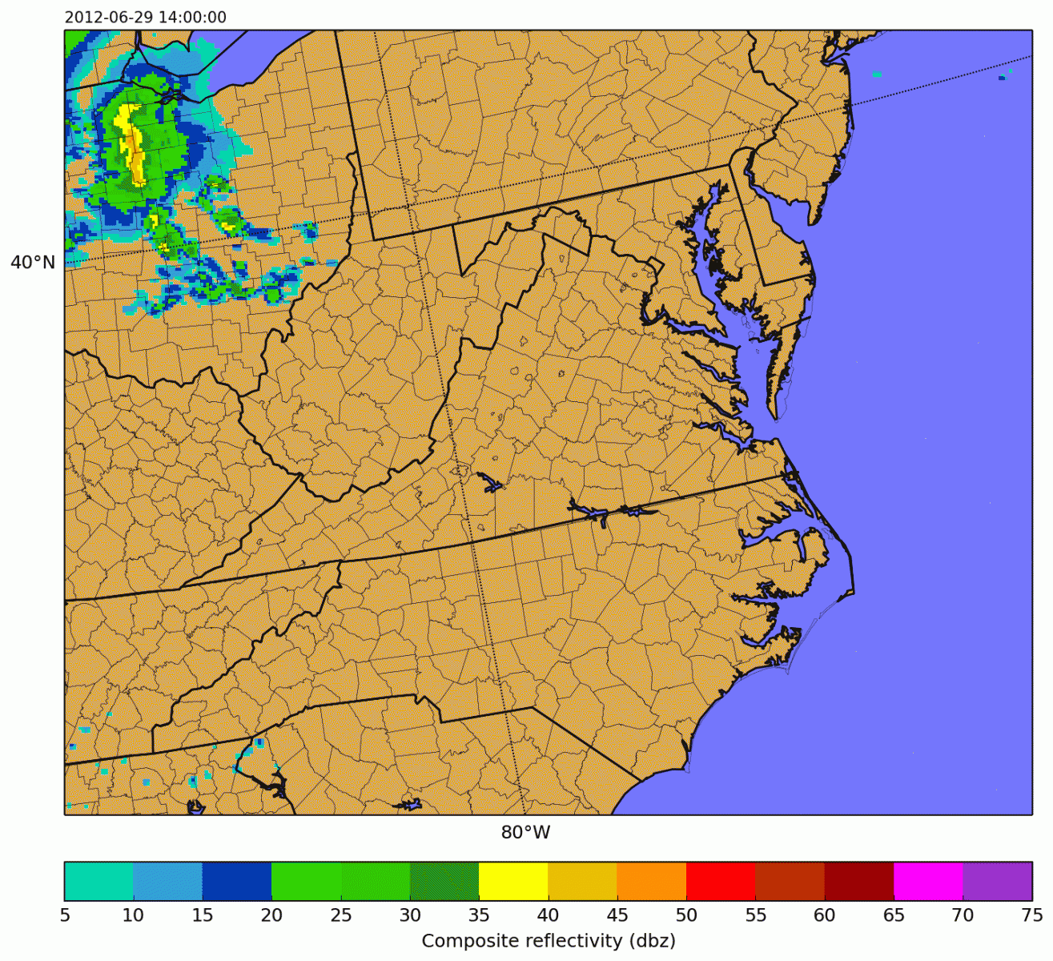

FV3 is able to resolve the path of storm systems on the scale of counties.

NOAA is developing its next generation global prediction system, and at its heart is the [Finite­ Volume Cubed-Sphere dynamical core (FV3)](http://www.noaa.gov/media-release/noaa-to-develop-new-global-weather-model) modernizing the National Weather Service’s approach to weather modelling.

A dynamical core takes equations describing movement in the atmosphere, such as moisture traveling through the water cycle, and translates them into computer-solvable language. It’s the engine of a weather forecast model , tracking how the Earth’s atmosphere is changing and what weather might develop as a result, but it doesn’t have all the parts needed to make a forecast. Every model needs three fundamental pieces: a dynamical core, a set of physics equations representing weather processes, and data about the real atmospheric conditions before forecasting.

The complexity and scope of [numerical weather prediction](http://www.noaa.gov/stories/weather-prediction-its-math) means supercomputers are also essential to forecasting. And as computer power increases with each new generation, weather models improve exponentially alongside them.

The National Weather Service’s current Global Forecasting System (GFS) has been the foundation of our suite of weather models for over 30 years. But throughout that time, technology has improved and scientists have found new approaches to processing data. [NOAA Research](http://research.noaa.gov/) has taken the steps to replace the GFS’s components with newer, more efficient and more accurate processes.

FV3 is the first step. It was developed in NOAA Research’s [Geophysical Fluid Dynamics Laboratory](http://www.gfdl.noaa.gov/) initially to power climate models and was then adapted for detailed global weather prediction. The NWS chose FV3 as the new GFS’s dynamical core in part because it uses less computer resources than other options. FV3 brings unprecedented accuracy to forecasts in three important ways:

* Computer Usage — FV3 is designed to efficiently scale to the available resources on any supercomputer for faster, higher resolution images. The current GFS, developed before the age of high speed computers, is not able to provide such highly detailed informations. Even if it ran on a computer with more processing power, it would not work faster.
* Vertical Equations — FV3 uses vertical equations to limitlessly zoom down to local scales and provide images of up-down air fluctuations, allowing us to resolve thunderstorms and their updraft winds. Older models assume the atmosphere experiences equal forces from above and below. This assumption can provide accurate prediction over large areas, but is unable to see the small-scale fluctuating winds that can lead to severe weather.
* Representation — FV3 represents weather through points in connected grid cells, so it can resolve weather that comes in irregular shapes. The current GFS represents all weather as waves. It’s been successful in large-scale modelling, but weather phenomena do not always follow wave patterns on the local level. For example, thunderstorms and cold fronts have sharp edges that a wave shape can not fully capture.

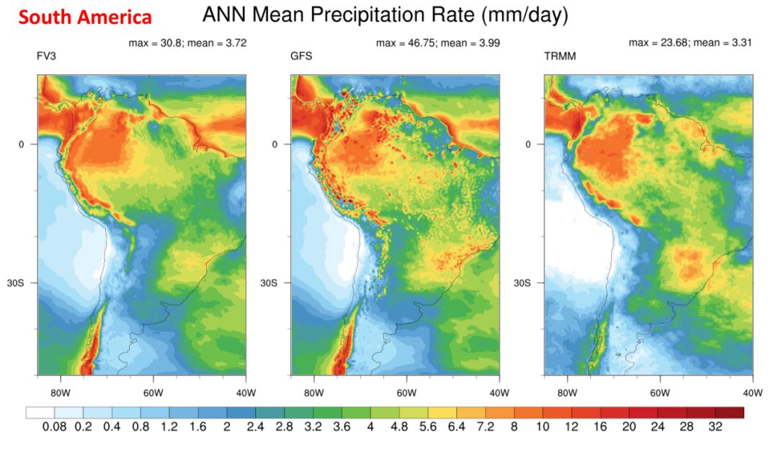

A comparison between the current GFS and FV3 modelling annual mean rainfall across South America. The results from the Tropical Rainfall Measuring Mission (TRMM) show what actual values were. FV3 can resolve small-scale features without the dot-like distortion current GFS shows, which represents false storms.

NWS and NOAA Research scientists are phasing in the GFS with FV3; it is being run experimentally with the target of going operational in 2019. Our new global model aims to deliver better, more timely forecasts to serve the growing needs of our forecasters and the weather enterprise.